**Introduction to Docker:**

Docker is an open-source platform designed to automate the deployment, scaling, and management of applications using containerization. It allows developers to package applications along with all their dependencies into a single container, ensuring consistent performance across different environments.

**Why Use Docker?**

* **Portability:** Docker containers run the same on any system that supports Docker—whether it's a developer's laptop, a testing environment, or production server.
* **Efficiency:** Containers are lightweight and share the host system’s kernel, using fewer resources compared to traditional virtual machines.
* **Speed:** Starting, stopping, and restarting containers is extremely fast, making it ideal for CI/CD workflows.
* **Isolation:** Applications and their dependencies are isolated in containers, which improves security and avoids conflicts between different projects.

**Key Components of Docker:**

* **Dockerfile:** A script containing instructions to build a Docker image.
* **Docker Image:** A snapshot of an application and its environment.
* **Docker Container:** A running instance of an image.
* **Docker Hub:** A cloud-based registry to store and share Docker images.
* **Docker Engine:** The runtime that builds and runs containers.

**Use Cases of Docker:**

* Microservices architecture
* Continuous Integration / Continuous Deployment (CI/CD)
* DevOps and automation
* Cloud-native applications
* Testing and debugging in isolated environments

**1. Write a Dockerfile (1.5 marks)**

* **Purpose:** Define the environment and steps to build the application container image.
* **Details:** A Dockerfile is a text document containing instructions like:
  + FROM: Base image
  + COPY, ADD: Add files to the container
  + RUN: Run commands (e.g., install dependencies)
  + CMD or ENTRYPOINT: Specify the default command to run when the container starts

**2. Build the Docker Image (1.5 marks)**

* **Purpose:** Create a portable, reusable container image based on the Dockerfile.
* **Command:** docker build -t <image-name> .
* **Details:** This generates a layered image that can be stored and shared. Layers are cached for efficient rebuilding.

**3. Test the Docker Image Locally (1 mark)**

* **Purpose:** Ensure the container behaves as expected in a local environment.
* **Command:** docker run -it <image-name>
* **Details:** This step helps catch bugs or misconfigurations early.

**4. Tag the Docker Image (1 mark)**

* **Purpose:** Version control and identification of the image.
* **Command:** docker tag <image-name> <repo-name>:<tag>
* **Details:** Tags help differentiate between development, staging, and production images.

**5. Push the Image to a Docker Registry (1.5 marks)**

* **Purpose:** Make the image accessible to others or for deployment.
* **Command:** docker push <repo-name>:<tag>
* **Details:** Common registries: Docker Hub, GitHub Container Registry, or private registries.

**6. Pull the Image on Target Environment (1 mark)**

* **Purpose:** Retrieve the image for use on production or another machine.
* **Command:** docker pull <repo-name>:<tag>
* **Details:** Ensures consistency across environments.

**7. Run Containers (1.5 marks)**

* **Purpose:** Launch a running instance of the Docker image.
* **Command:** docker run -d -p 80:80 <repo-name>:<tag>
* **Details:** Options include port mapping, volume mounting, environment variables, etc.

**8. Monitor and Manage Containers (1 mark)**

* **Purpose:** Maintain performance and stability in production.
* **Commands:** docker ps, docker logs, docker stop, docker restart
* **Details:** Helps troubleshoot and manage running containers.

**9. Update and Rebuild (1 mark)**

* **Purpose:** Apply updates (code, dependencies) and regenerate images.
* **Details:** Update Dockerfile or source code and repeat the build–test–deploy cycle.

**🔍 Real-Life Example of Docker:**

**Scenario: Web Application Deployment**

Imagine a company that develops an e-commerce website using technologies like Node.js for the backend, React for the frontend, and MongoDB as the database.

**Without Docker:**

* Developers need to install the right versions of Node.js, React, and MongoDB on their local machines.
* Sometimes it works on one machine but fails on another due to version mismatches.
* Deploying to production requires manual setup of environments, which can be error-prone.

**With Docker:**

1. Developers write a **Dockerfile** for the backend, frontend, and database.
2. Each part of the application is containerized and runs the exact same way in development, testing, and production.
3. The whole application stack can be started with a single command using **Docker Compose**.
4. No more "It works on my machine" issues—because containers behave the same everywhere.

**Result:**

* Faster development and testing
* Easier deployment to cloud platforms like AWS, Azure, or Google Cloud
* Better collaboration between developers and DevOps teams

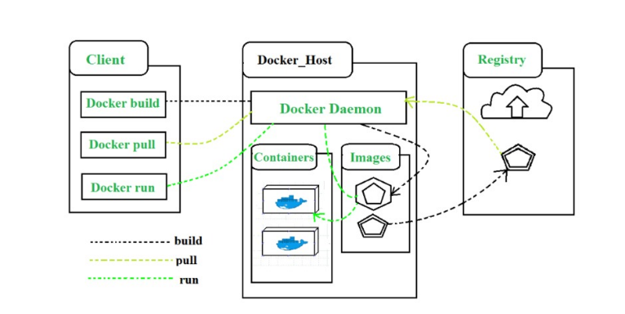

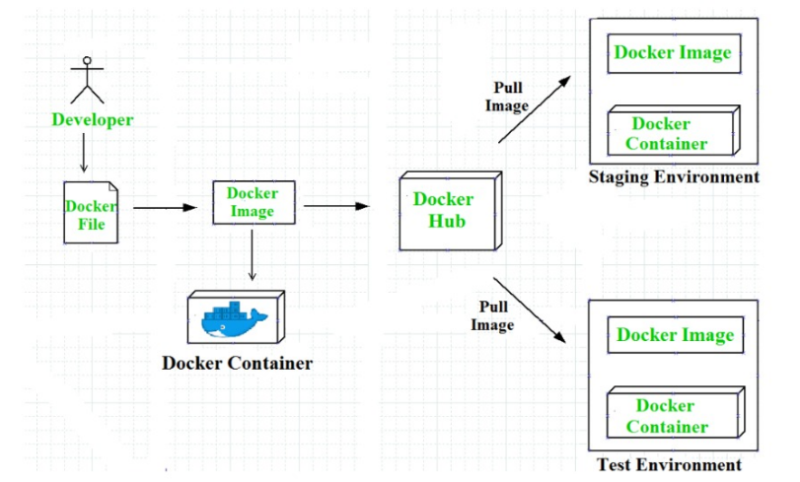

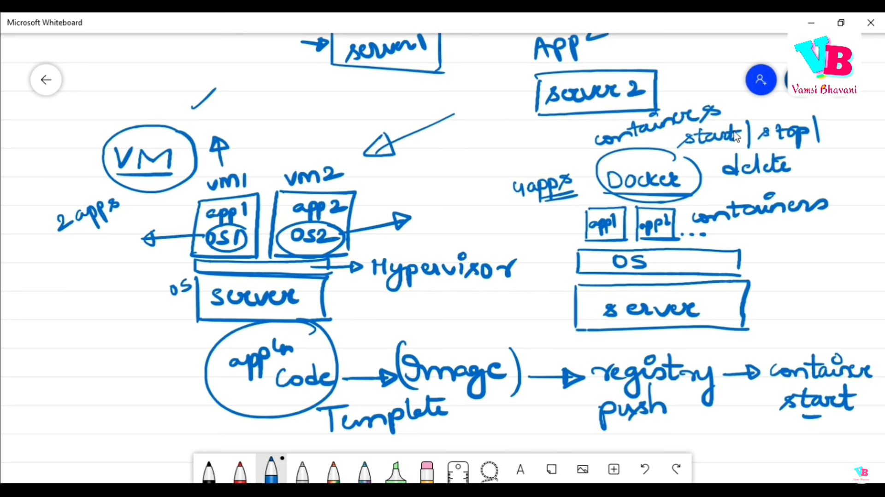

**✅ What is Virtualization?**

**Virtualization** is a technology that allows you to create multiple simulated environments or dedicated resources from a single physical hardware system. In simple terms, it lets you **run multiple operating systems or applications on a single machine**, by abstracting the hardware layer using software called a **hypervisor**.

There are two main types of hypervisors:

* **Type 1 (Bare-metal):** Runs directly on the hardware (e.g., VMware ESXi, Microsoft Hyper-V).
* **Type 2 (Hosted):** Runs on a host operating system (e.g., Oracle VirtualBox, VMware Workstation).

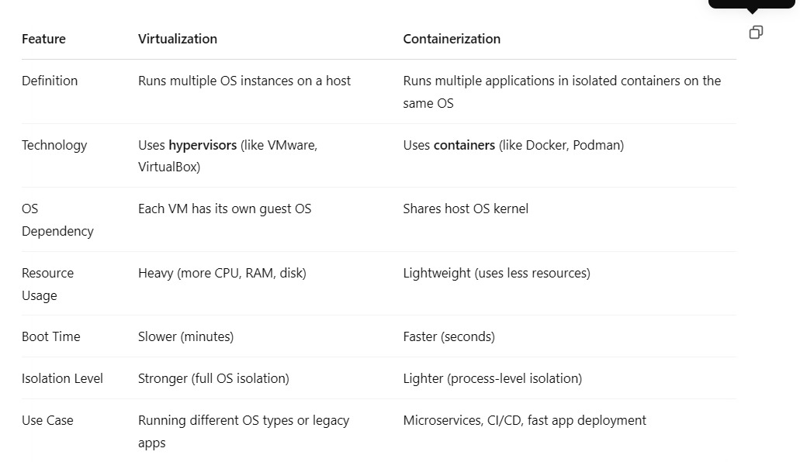

**Advantages:**

Cost Efficiency

Resource Optimization

Isolation

Flexibility and Scalability

Disaster Recovery & Backup

Testing & Development

Sure, Goldy! Here's how you can **ask your students** this question in a clear and engaging way:

**🧑‍🏫 Question for Students:**

❓ **Explain the benefits of using containers in DevOps. How do containers help in the DevOps pipeline? Provide suitable examples.**

**✍️ What You Expect from Students' Answer:**

Their answer should cover:

* What containers are
* How they work in DevOps
* Key benefits like portability, consistency, scalability
* Their role in CI/CD pipelines (build, test, deploy)
* Real-world examples (e.g., Docker + Jenkins, Kubernetes)

**✅ Sample Student Answer (for reference):**

**Containers** are lightweight, portable environments that bundle applications with all their dependencies. In **DevOps**, they play a crucial role by ensuring consistency across development, testing, and production.

**🔹 Benefits in DevOps:**

* **Portability:** "It works on my machine" problems are avoided.
* **Faster Deployment:** Containers start quickly, speeding up testing and delivery.
* **Isolation:** Each app runs in its own container without conflict.
* **Scalability:** Containers can be easily scaled using tools like Kubernetes.
* **Version Control:** Container images are versioned and traceable.

**🔹 In the DevOps Pipeline:**

* In the **Build stage**, developers containerize their apps using Docker.
* In the **Test stage**, containers provide identical environments for automated testing.
* In the **Deploy stage**, the same container image is pushed to staging or production using CI/CD tools like **Jenkins**, **GitLab CI**, or **GitHub Actions**.

**Example:** A team uses Jenkins to build a Node.js app into a Docker image. The image is tested and then deployed to AWS using Kubernetes.

**✅ Example of Virtualization:**

**Example: Software Testing on Multiple Operating Systems**

A software developer needs to test a web application on **Windows**, **Linux**, and **macOS** to ensure it works properly across all platforms.

Instead of buying three different computers, the developer uses **virtualization** on a single laptop to create:

* A **Windows virtual machine**
* A **Linux virtual machine**
* A **macOS virtual machine**

Each VM runs independently and allows the developer to test the application in different environments—all from one physical system.

**MySql in Docker**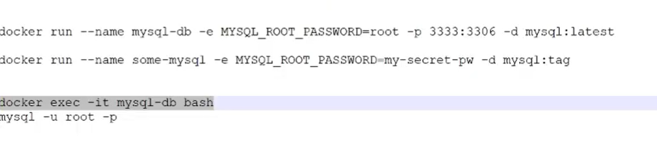

🧠 Kubernetes – Explained for Exams

✅ Definition:

Kubernetes is an open-source container orchestration platform that automates the deployment, scaling, and management of containerized applications. It ensures that your applications are running smoothly and can recover from failures automatically.

It was originally developed by Google and is now maintained by the Cloud Native Computing Foundation (CNCF).

✅ Why Kubernetes is Needed:

Running a few containers with Docker is easy. But when you have hundreds or thousands of containers, managing them manually becomes impossible. Kubernetes solves this by automating:

* Deployment
* Scaling
* Load balancing
* Health checks
* Rolling updates

⚙️ Key Components of Kubernetes:

1. Cluster: A group of machines (nodes) managed by Kubernetes.
2. Master Node: Controls the cluster and makes decisions (scheduling, scaling, etc.).
3. Worker Nodes: Run the containers (also called Minions).
4. Pod: The smallest unit, usually runs one or more containers.
5. Service: Defines a network access point to pods, used for load balancing.
6. Deployment: Manages updates and scaling of pods automatically.

🌐 Key Features:

* Self-Healing: Automatically replaces failed containers.
* Horizontal Scaling: Increases or decreases the number of pods based on load.
* Rollbacks & Updates: Supports zero-downtime deployments.
* Resource Monitoring: Efficient use of hardware.

🛠️ Real-Life Example:

A company like Netflix runs microservices for user profiles, video streaming, recommendations, etc. With Kubernetes, each service is deployed in a container, and Kubernetes ensures:

* All services are up
* Traffic is balanced
* New updates are rolled out without downtime

📝 Conclusion:

Kubernetes is a powerful tool that makes managing containerized applications at scale easier and more reliable. It is a key technology in modern DevOps and cloud-native development.

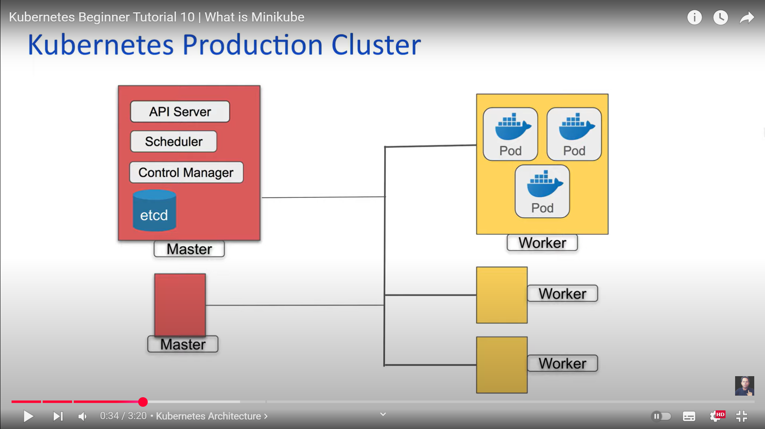

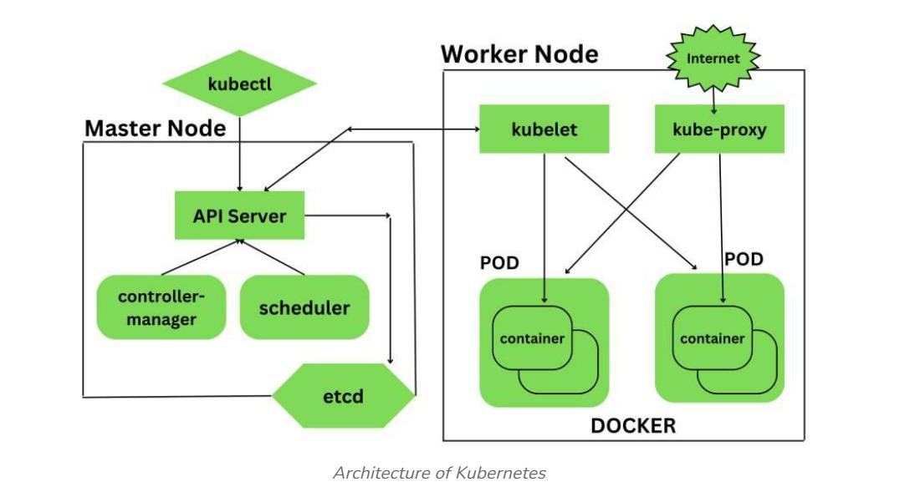

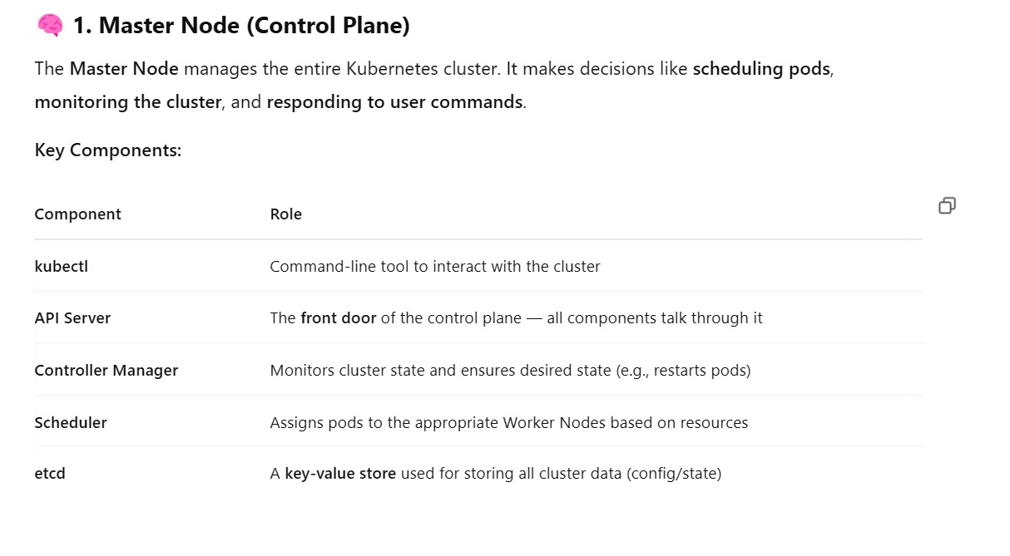

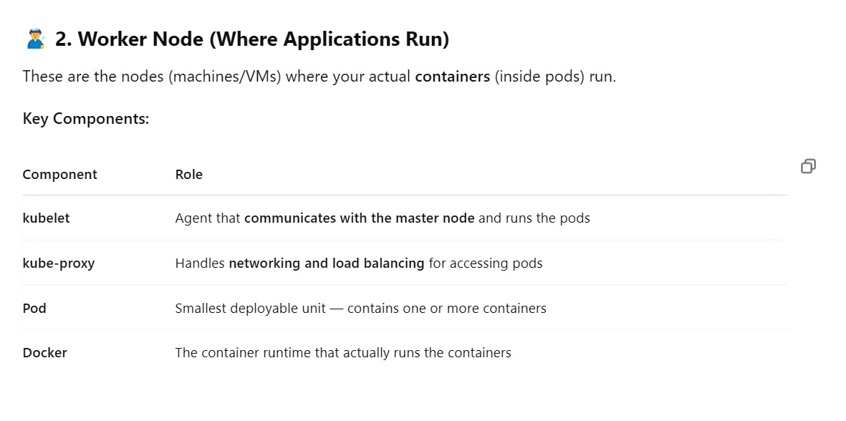

🐬⚙️ MySQL in Docker with Kubernetes – Detailed Explanation

🔹 Step 1: What is Docker and Why Use it for MySQL?

Docker is a containerization platform. When we use MySQL in Docker:

* We get a lightweight, isolated environment.
* No need to install MySQL manually — we just pull the image from Docker Hub.
* Easy to configure using environment variables (e.g., password, DB name).
* Ideal for development, testing, and even production.

🔹 Step 2: What is Kubernetes and Why Use it with Docker?

Kubernetes (K8s) is a container orchestration platform. While Docker runs the MySQL container, Kubernetes helps manage it on a larger scale.

Using Kubernetes for MySQL:

* Ensures the container is always running (self-healing).
* Provides networking, so other services (like a backend app) can connect to MySQL.
* Manages storage with Persistent Volumes (PV).
* Supports scaling, rolling updates, and auto-recovery.

🛠️ Step 3: Deploying MySQL in Kubernetes (with Docker)

To deploy MySQL in Kubernetes, we usually define YAML files with:

1. Deployment

* Describes the MySQL container (image, ports, env variables).
* Ensures the pod is always running.
* Manages pod lifecycle (restart if it crashes).

2. Persistent Volume Claim (PVC)

* Keeps your data safe even if the pod stops or restarts.
* Mounted inside the container as /var/lib/mysql.

3. Service

* Provides a fixed network address for other pods to connect to MySQL (like backend apps).
* Acts as a load balancer if we run multiple MySQL replicas (advanced case).

📦 How MySQL Deployment Works in Kubernetes:

1. Kubernetes creates a pod using the MySQL Docker image.
2. It mounts storage from a PVC to save MySQL data.
3. A Service is created to allow access from other apps inside the cluster.
4. If the pod fails, Kubernetes automatically restarts it.
5. The data is safe because it's stored in a Persistent Volume.

✅ Benefits of Using MySQL in Docker + Kubernetes

| Feature | Benefit |
| --- | --- |
| 🐳 Docker | Lightweight, fast setup, portable MySQL instance |
| 📦 Kubernetes | Automatic scaling, recovery, and orchestration |
| 💾 Persistent Volume | Data durability — survives restarts |
| 🔄 Self-healing | Restarts MySQL automatically if it crashes |
| 🔗 Service | Easy, reliable access from other apps |

💡 Real-Life Example

Let’s say you're building an online bookstore application. It has:

* A frontend (React)
* A backend (Node.js)
* A MySQL database (for users, orders, books)

Here’s what happens:

* You create a MySQL Docker container.
* Deploy it in Kubernetes using a YAML file.
* Attach a Persistent Volume to store data.
* Backend pods connect to MySQL using the Kubernetes service name.
* If the MySQL pod fails, Kubernetes restarts it — no downtime.

📝 Conclusion (To Write in Exam):

Using Docker and Kubernetes together allows us to deploy MySQL in a fast, reliable, and scalable way. Docker provides isolation and portability, while Kubernetes manages container orchestration, health checks, storage, and networking. This setup is ideal for modern DevOps pipelines and real-world cloud applications**.**

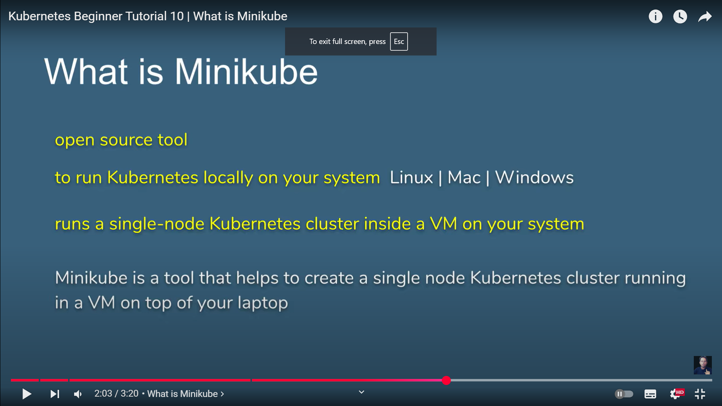

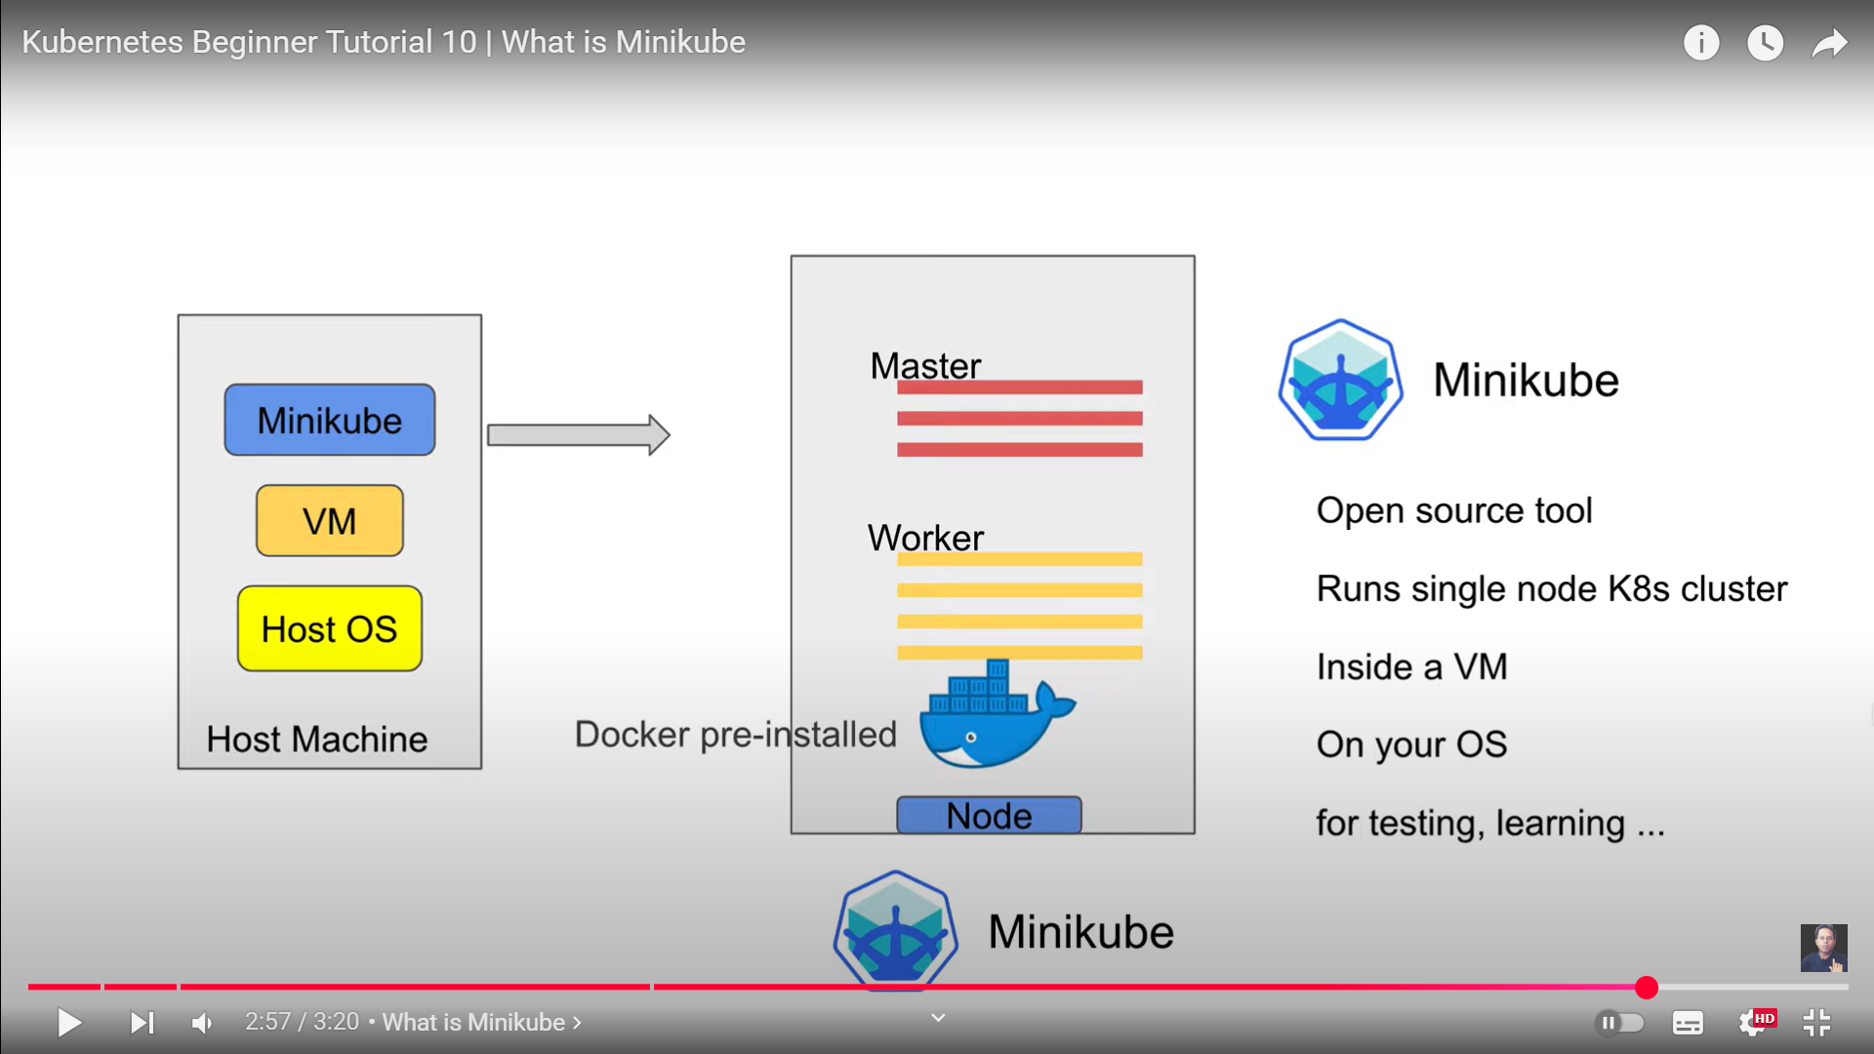

**🚀** What is Minikube?

Minikube is a tool that lets you run Kubernetes locally on your personal computer.

It creates a single-node Kubernetes cluster in a virtual machine (VM) so you can:

* Learn Kubernetes
* Develop and test Kubernetes applications
* Practice DevOps workflows — without needing a cloud environment

✅ Why Use Minikube?

* Lightweight and easy to install
* Works on Windows, macOS, and Linux
* Great for students, developers, and DevOps engineers
* Doesn't require a cloud platform like AWS or GCP

🛠️ Minikube Installation Steps

Below are the standard installation steps for Windows, macOS, and Linux. You can write any one of them in exams based on what’s asked.

💻 For Windows:

Step 1: Install Docker or Hyper-V

Minikube requires a VM driver. Install Docker Desktop or enable Hyper-V (Windows feature).

Step 2: Install Minikube

Download Minikube using Chocolatey (package manager):

bash

CopyEdit

choco install minikube

Or manually download from the official site:  
https://minikube.sigs.k8s.io/docs/start/

Step 3: Start Minikube

bash

CopyEdit

minikube start

Step 4: Verify Installation

bash

CopyEdit

kubectl get nodes

**-----------------------------------------------------------------------------------**

**pod configuration on windows**

**📝 Step 1: Create a YAML file to define the Pod**

Create a file named mypod.yaml using Notepad or VS Code with the following content:

yaml

CopyEdit

apiVersion: v1

kind: Pod

metadata:

name: myapp-pod

labels:

app: myapp

spec:

containers:

- name: myapp-container

image: nginx

ports:

- containerPort: 80

🧠 This defines a Pod named myapp-pod running an **nginx** web server on port 80.

**🧱 Step 2: Apply the YAML file to create the Pod**

Open **PowerShell or CMD** in the folder where your YAML file is saved:

bash

CopyEdit

kubectl apply -f mypod.yaml

**🔍 Step 3: Check Pod Status**

Use this command to see if the pod is running:

bash

CopyEdit

kubectl get pods

You should see output like:

sql

CopyEdit

NAME READY STATUS RESTARTS AGE

myapp-pod 1/1 Running 0 1m

**🔧 Step 4: Access Pod Logs (Optional)**

bash

CopyEdit

kubectl logs myapp-pod

**🧪 Step 5: Test Connectivity Inside the Cluster**

To enter the pod:

bash

CopyEdit

kubectl exec -it myapp-pod -- /bin/bash

Inside the pod, you can run Linux commands and check files or web server responses.

**📝 Conclusion (Exam Point):**

On Windows, Pods can be created using a YAML file and kubectl apply command. This allows developers to run and test containerized applications locally using Minikube. It’s a foundational step in learning Kubernetes.

**🛠️ Configuration Management Tools**

**✅ What is Configuration Management?**

**Configuration Management (CM)** is the process of **automating and maintaining consistency** of a system's configuration — including software, servers, networks, and infrastructure — over time.

Instead of doing manual setup, CM tools ensure that every environment (dev, test, prod) is **configured the same way**.

**📦 Why Configuration Management is Important:**

* Ensures **consistency** across systems
* Supports **automated deployment**
* Reduces **human error**
* Makes systems **easier to manage and scale**
* Helps in **disaster recovery**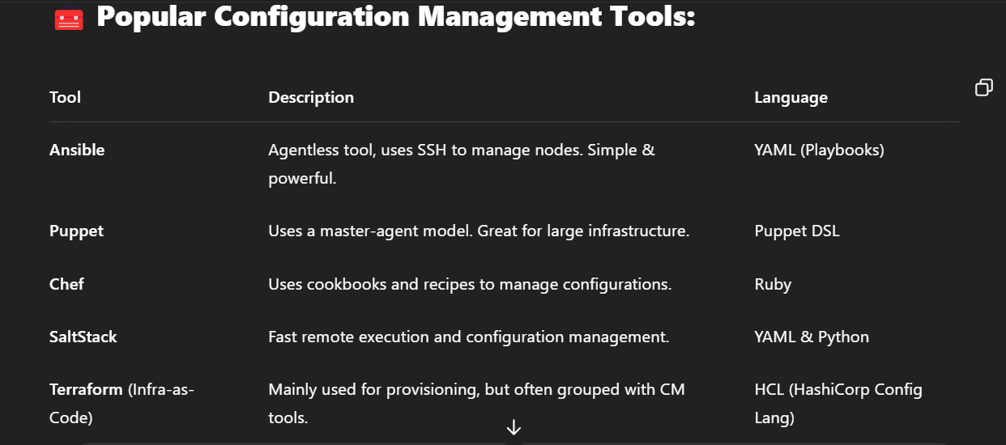
* 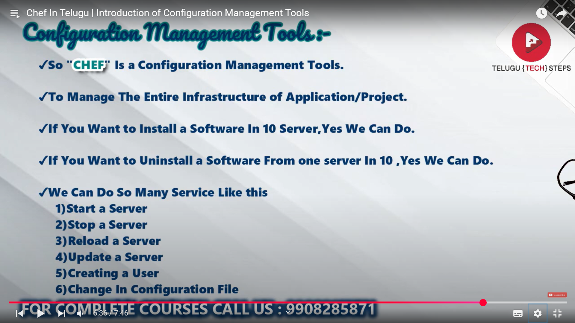

**👨‍🍳 What is Chef?**

**Chef** is an open-source **configuration management tool** used to **automate the infrastructure** provisioning and application deployment process.

It helps in defining infrastructure as **code** using a domain-specific language (DSL) written in **Ruby**.

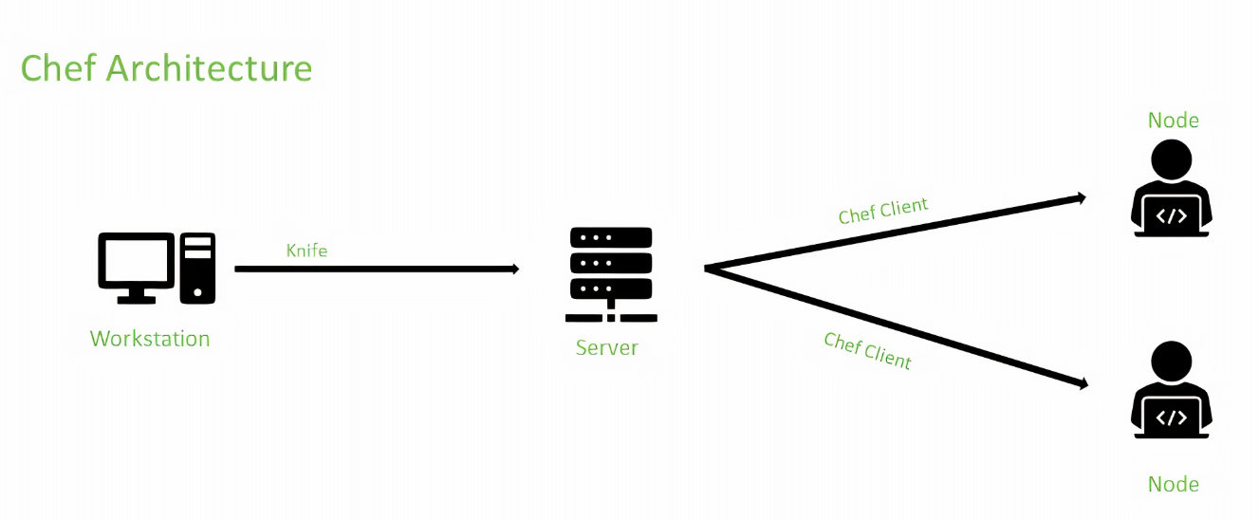

**Component of Chef Architecture :**  
Chef has major components such as Workstation, Cookbook, Node, and Chef-Server. Let us see the entire major component in detail.

1. **Workstation –**  
   The workstation is used to interact with Chef-server and Chef-nodes. It is also used to create Cookbooks. Workstation is a place where all the interaction takes place, where Cookbooks are created, tested and deployed, and in workstation, codes are tested. Workstation is also used for defining roles and environments based on the development and production environment.  
   Knife is used for interacting with Chef Nodes.
2. **Chef Server –**  
   Chef server contains all configuration data, it also stores cookbooks, recipes and metadata that describe each node in the Chef-Client. Configuration details are given to node through Chef-Client. Any changes made must pass through the Chef server to be deployed. Prior to pushing the changes, it verifies that the nodes and workstation are paired with the server through the use of authorization keys, and then allow for communication between workstations and nodes.
3. **Node –**  
   Nodes are managed by Chef and each node is configured by installing Chef-Client on it. Chef-Nodes are a machine such as physical, virtual cloud etc.
4. **Cookbooks –**  
   Cookbooks are created using Ruby language and Domain Specific languages are used for specific resources. A cookbook contains recipes which specify resources to be used and in which order it is to be used. The cookbook contains all the details regarding the work and it changes the configuration of the Chef-Node.

**Puppet**

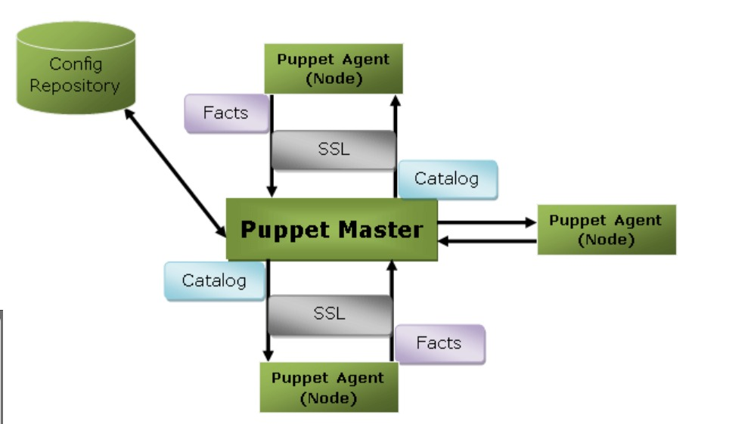

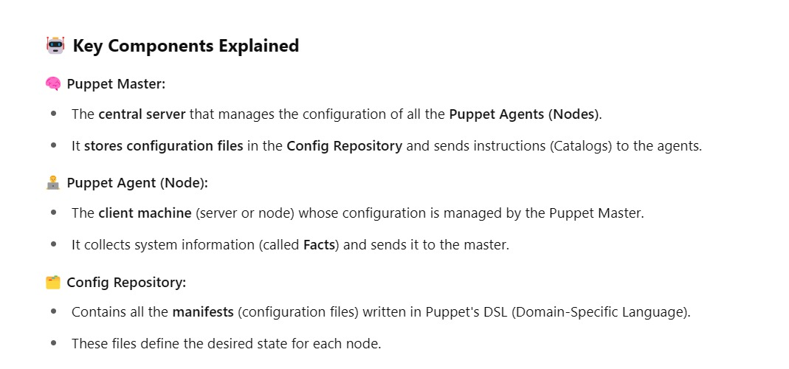

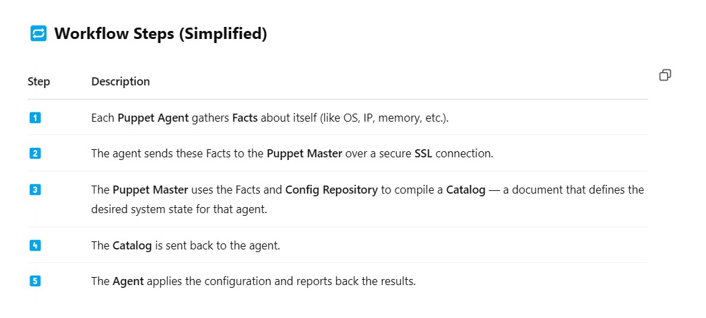

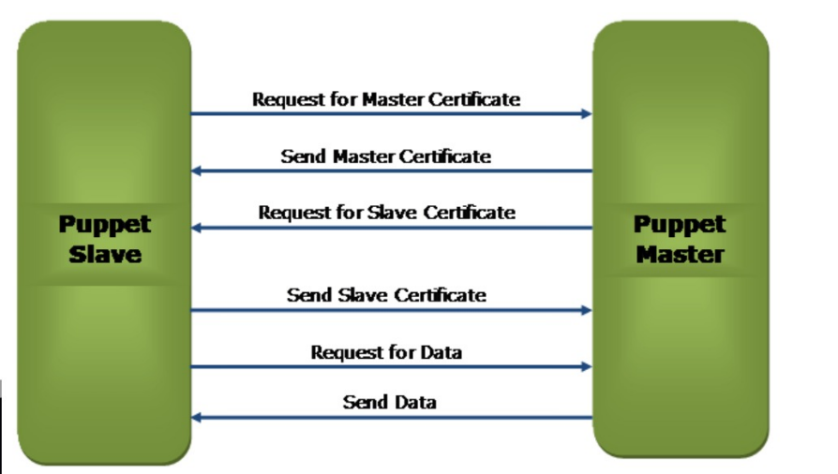**s**

